­­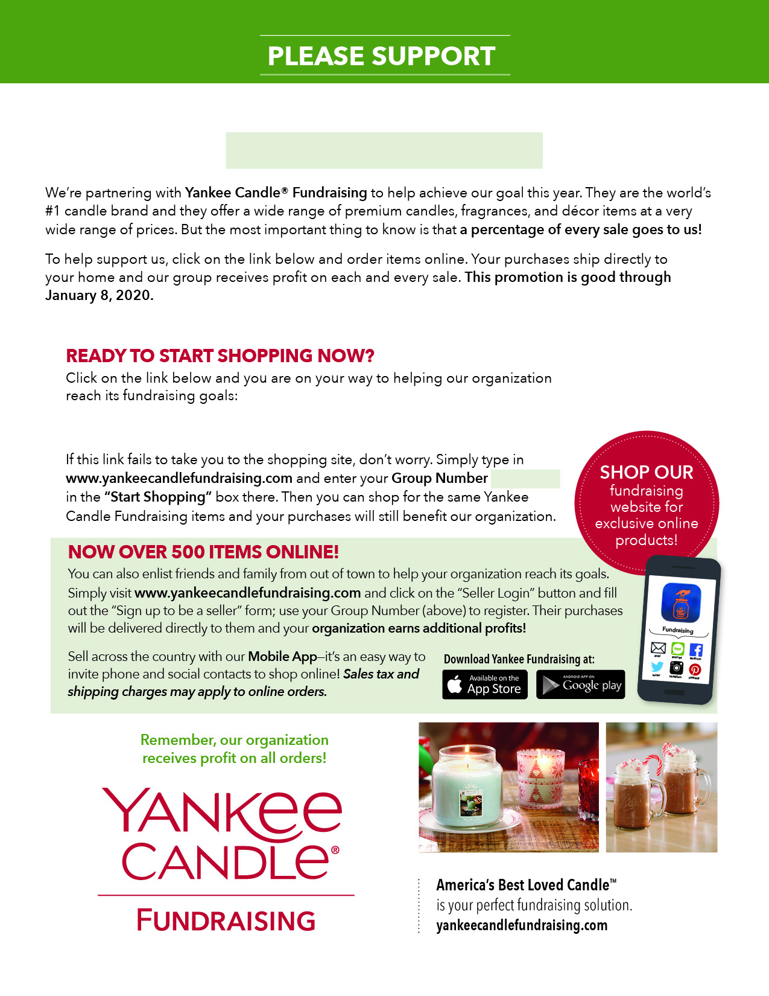

[NORTH SALEM HS JR-SR CLASS YANKEE CANDLE STORE](https://www.yankeecandlefundraising.com/scripts/ycfwcgi.exe?_V4=Process&_Func=enterWebsiteGroupEmail&frComp=ycf&cusId=999974902)

999974902

NORTH SALEM HS JR-SR CLASS

Group #999974902